**Assignment 2 Driver Analysis**

Create database indhudb;

Use indhudb;

CREATE EXTERNAL TABLE drivers(driverId int,name varchar(30),ssn int,location varchar(50),certified char(1),wage_plan varchar(10))

ROW FORMAT DELIMITED FIELDS TERMINATED BY ',' location '/user/mavricbdhoct08/drivers';

LOAD DATA LOCAL INPATH 'drivers.csv' INTO TABLE drivers;

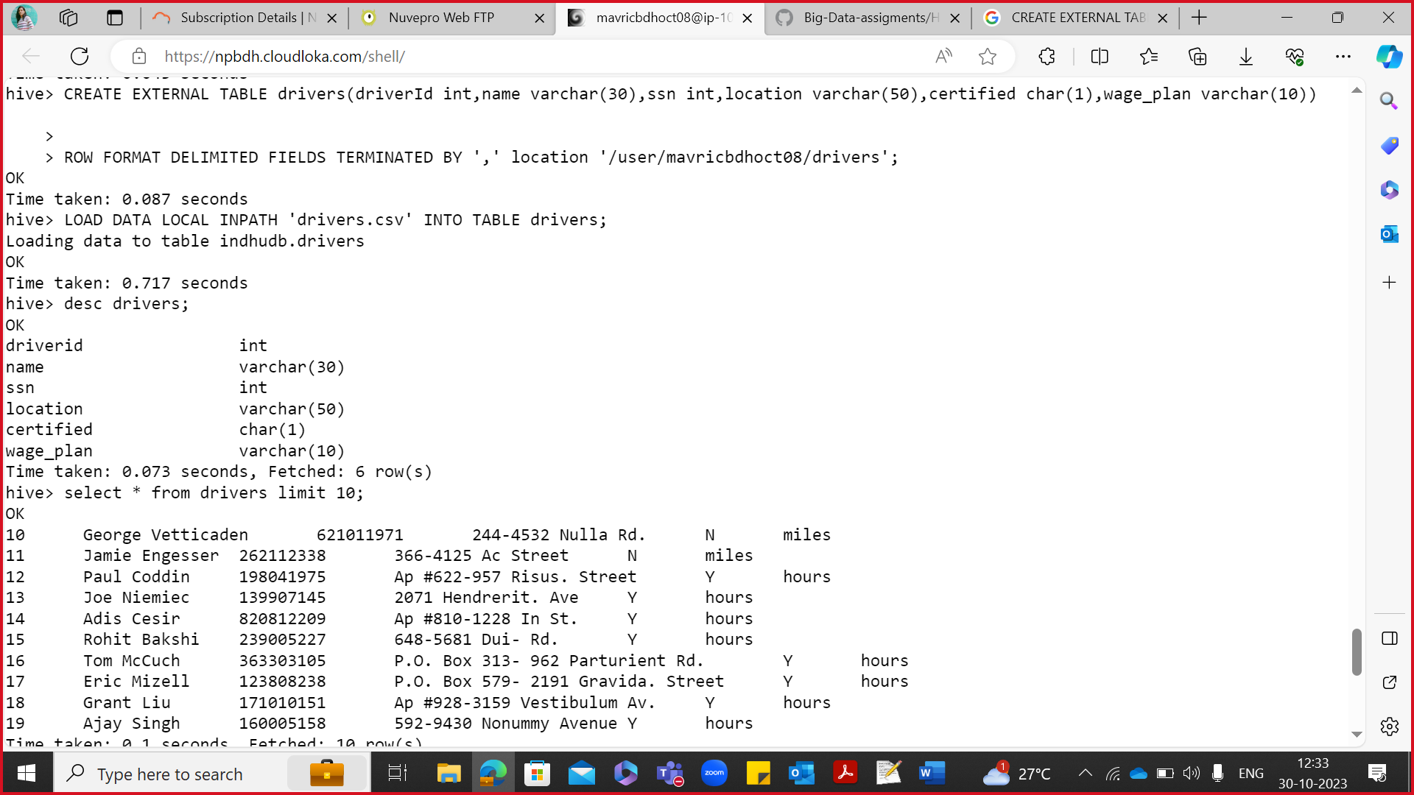

CREATE EXTERNAL TABLE timesheet(driverId int,week int,hours_logged int,miles_logged int)

ROW FORMAT DELIMITED FIELDS TERMINATED BY ',' location '/user/mavricbdhoct08/timesheet';

LOAD DATA LOCAL INPATH 'timesheet.csv' INTO TABLE timesheet;

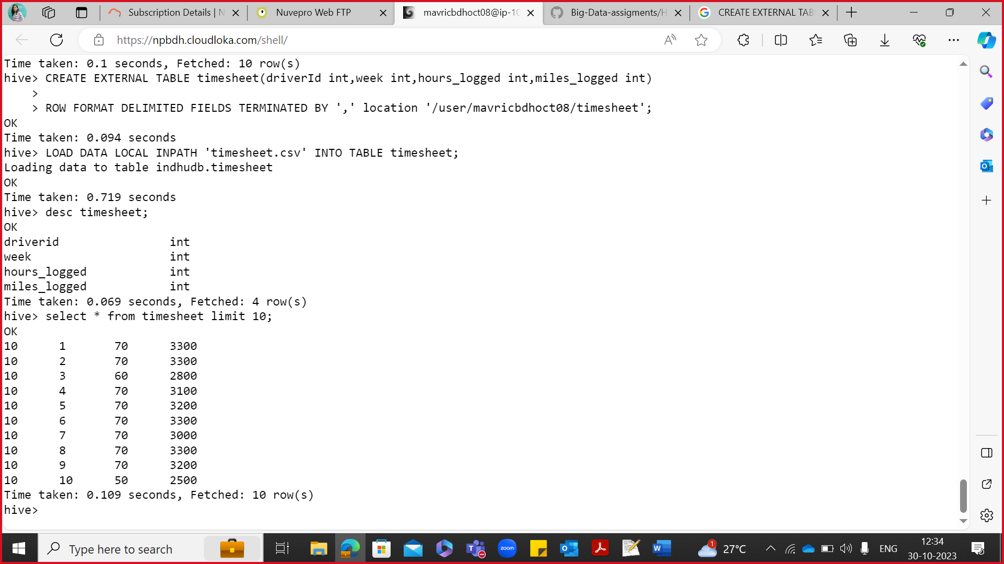

**How many total hours and miles logged by each driver?**

select driverId,sum(hours_logged) as total_hours, sum(miles_logged) as total_miles from timesheet group by driverId;

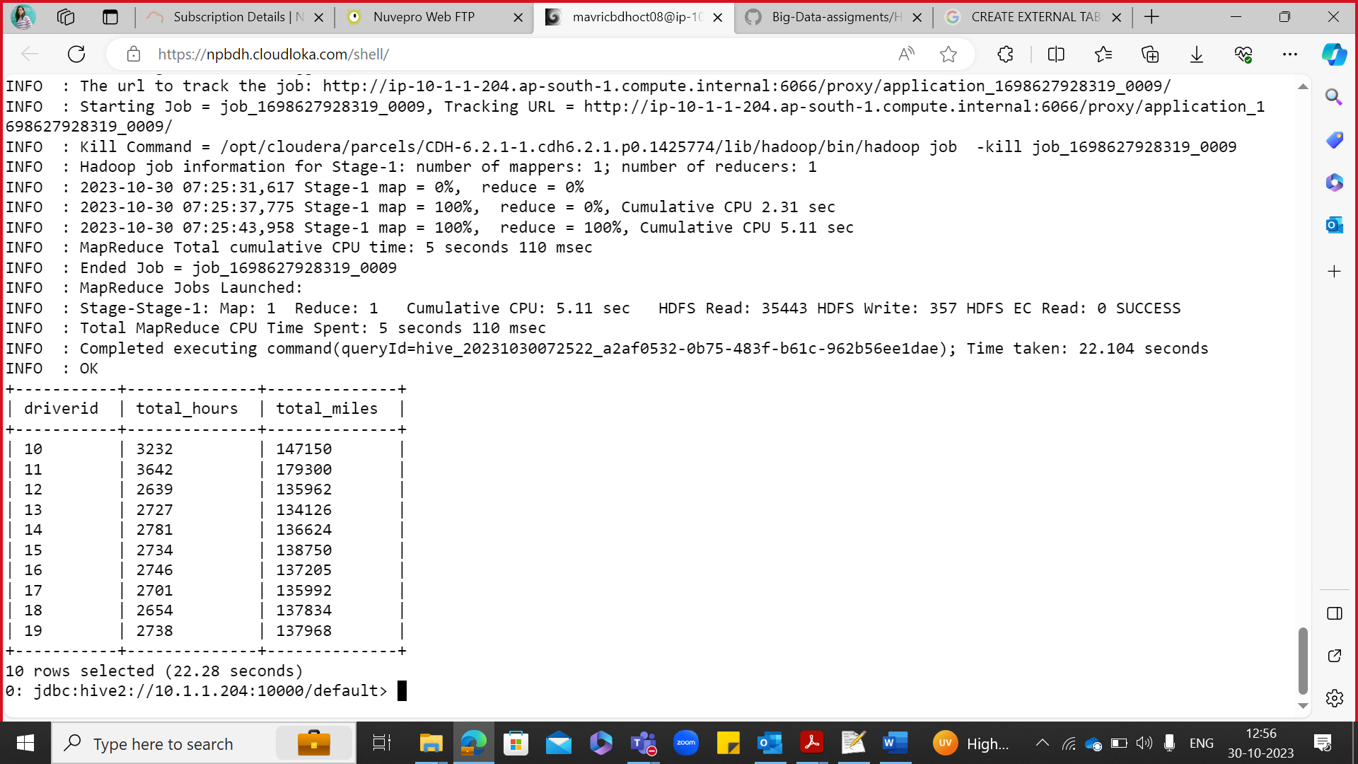

**Print the name of the driver in the above query**

select driverId,name,sum(hours_logged) as total_hours, sum(miles_logged) as total_miles from drivers D join timesheet T on D.driverId = T.driverId group by D.driverId,name;w

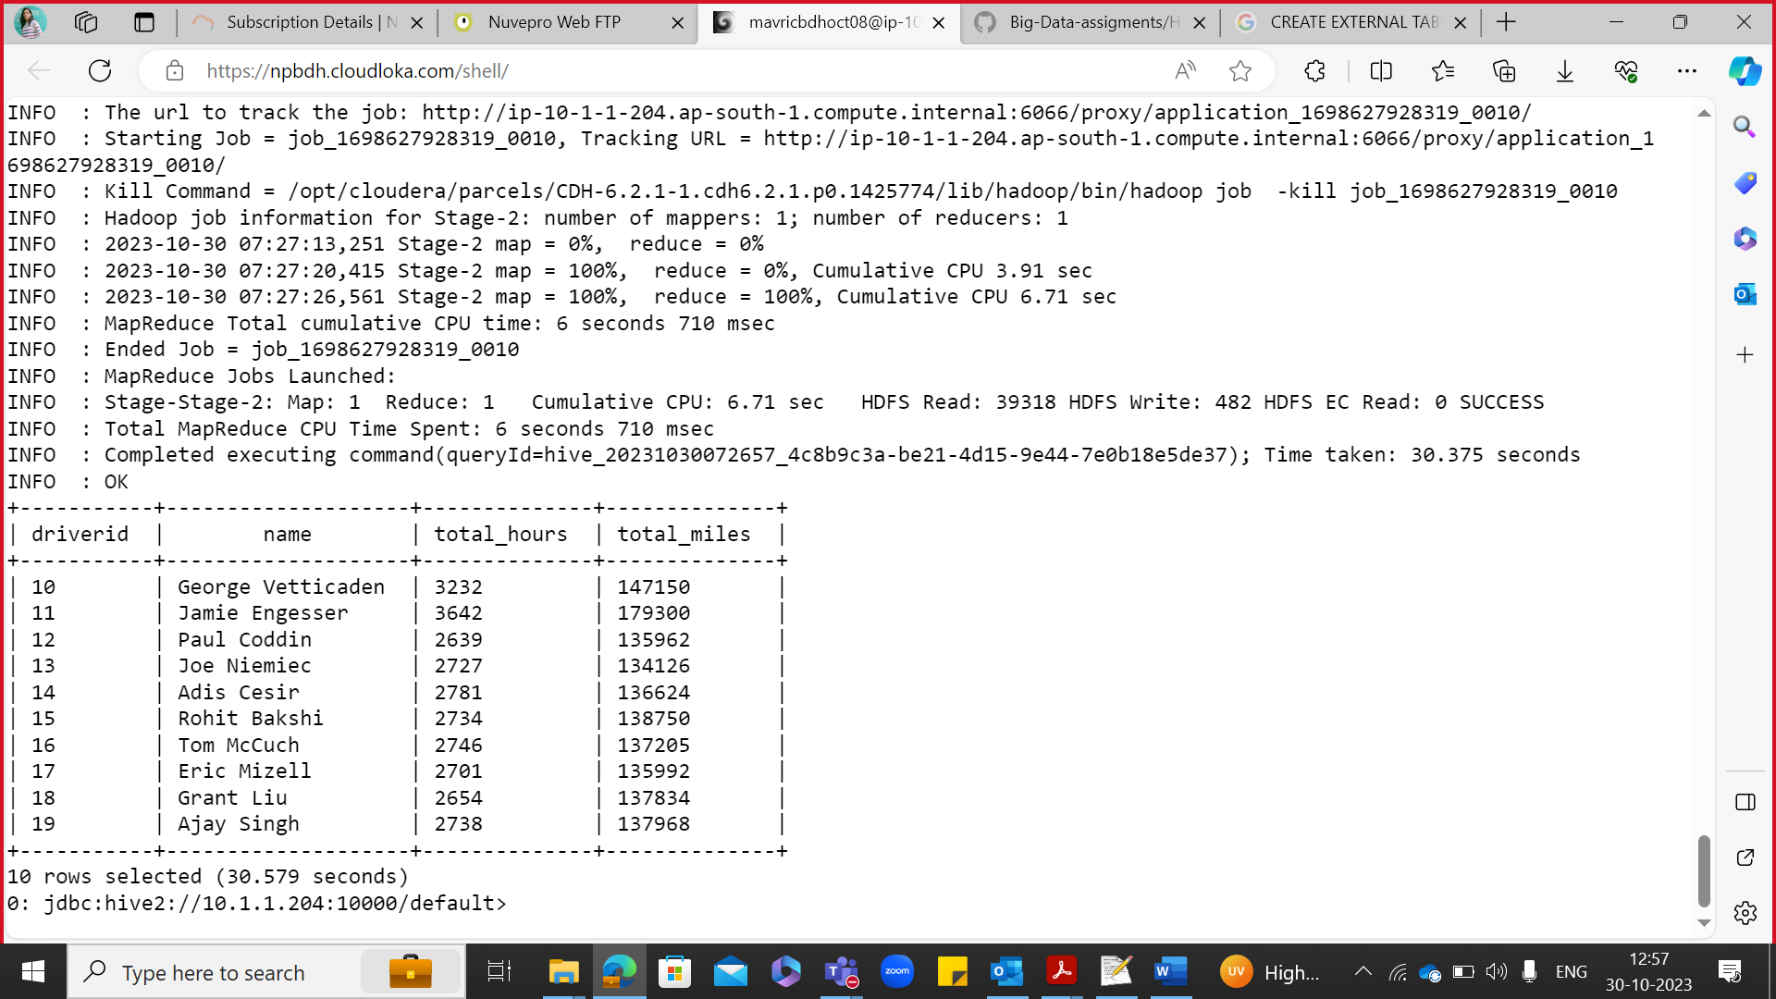

**Write the above query output in to hdfs directory**

vi test.sql

use indhudb;

insert overwrite directory 'output' select driverId,name,sum(hours_logged) as total_hours, sum(miles_logged) as total_miles from drivers D join timesheet T on D.driverId = T.driverId group by D.driverId,name;

hive -f sql.test

hdfs dfs -ls

hdfs dfs -ls output

hdfs dfs -cat output/00000_0

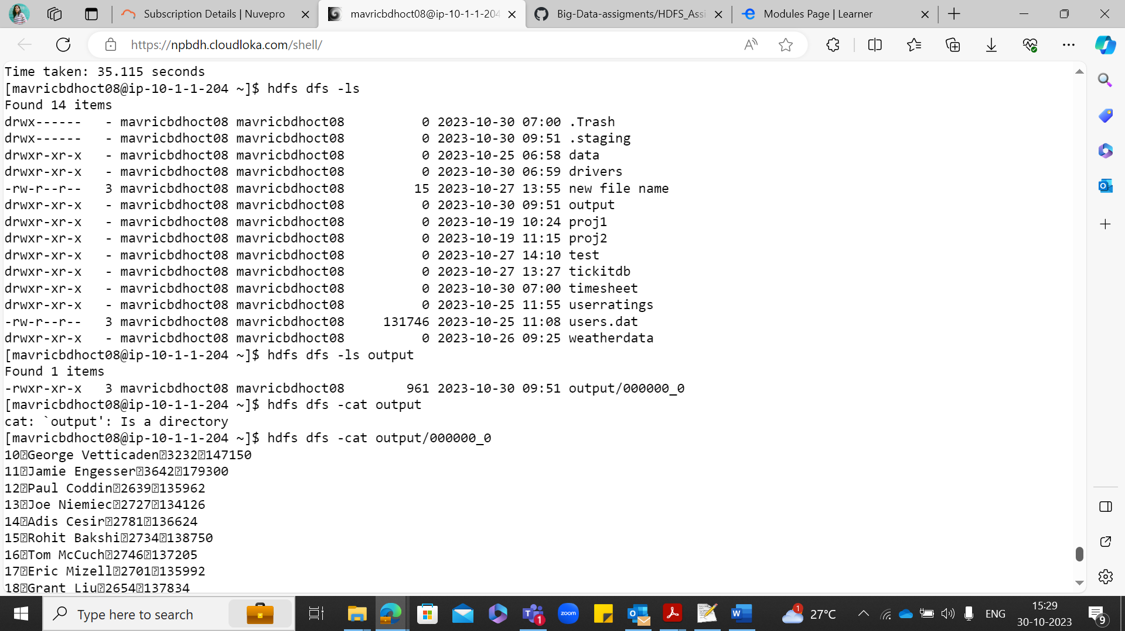

**facebook Analysis Assignment 1**

CREATE TABLE facebook(userid int,age int,dob_day int,dob_year int,dob_month int,gender varchar (10),tenure int,friend_count int,friendships_initiated int,

likes int,likes_received int,mobile_likes int,mobile_likes_received int,www_likes int,www_likes_received int) ROW FORMAT DELIMITED FIELDS TERMINATED BY ',';

LOAD DATA LOCAL INPATH 'pseudofacebook.csv' INTO TABLE facebook;

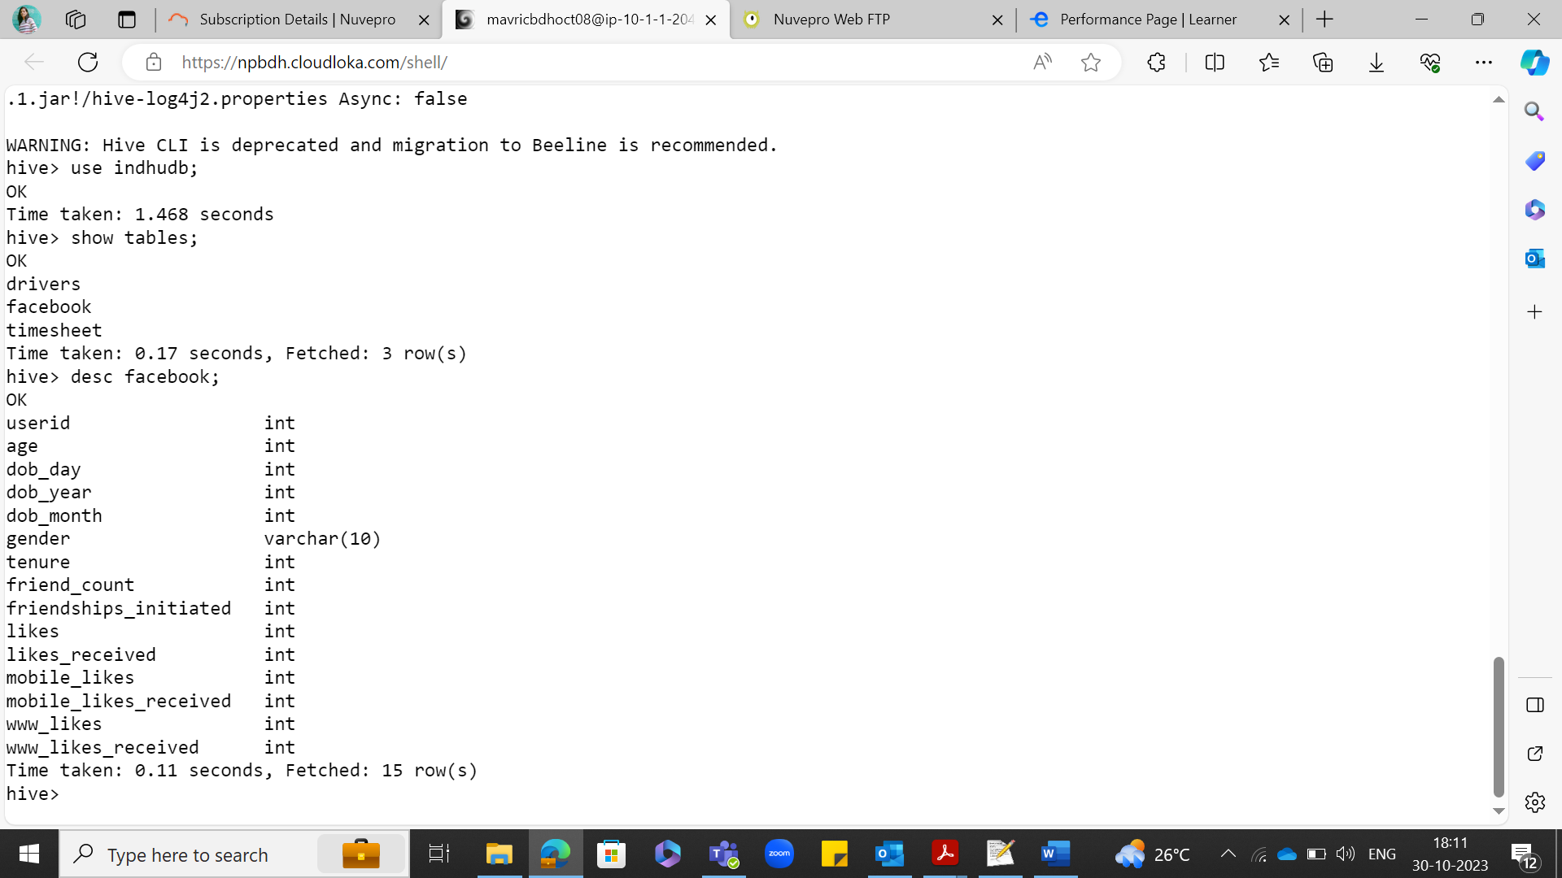

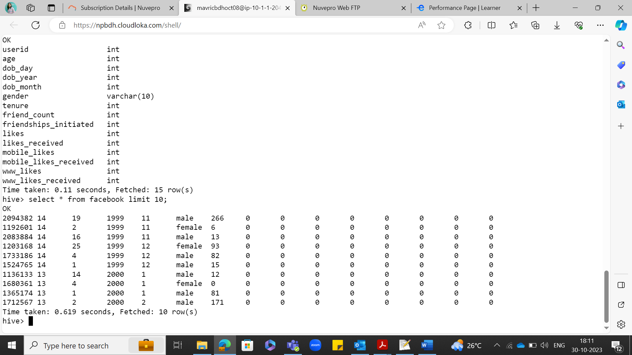

**Q1: Find out the total no of users in the dataset**

Select count(*) form facebook;

Select count(DISTINCT userid) from facebook;

**Ans: 99003**

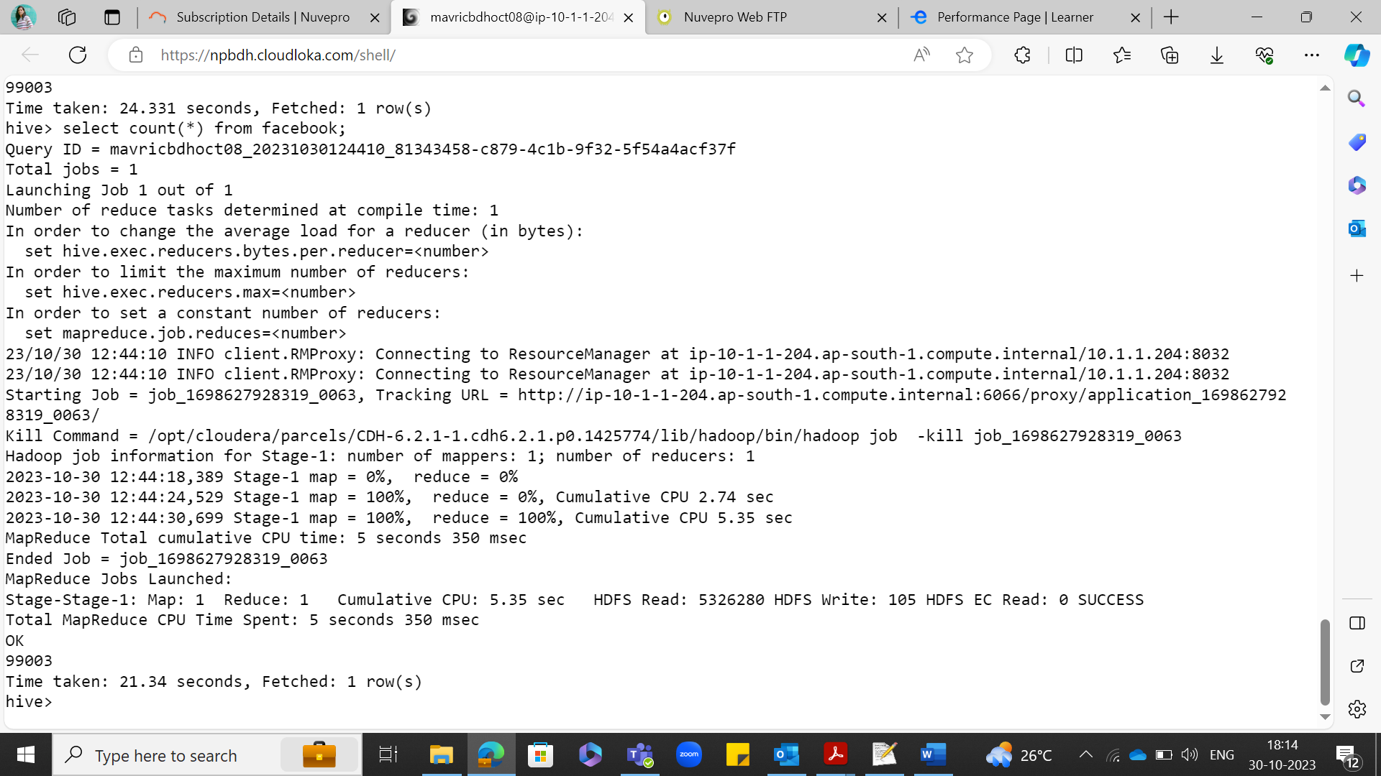

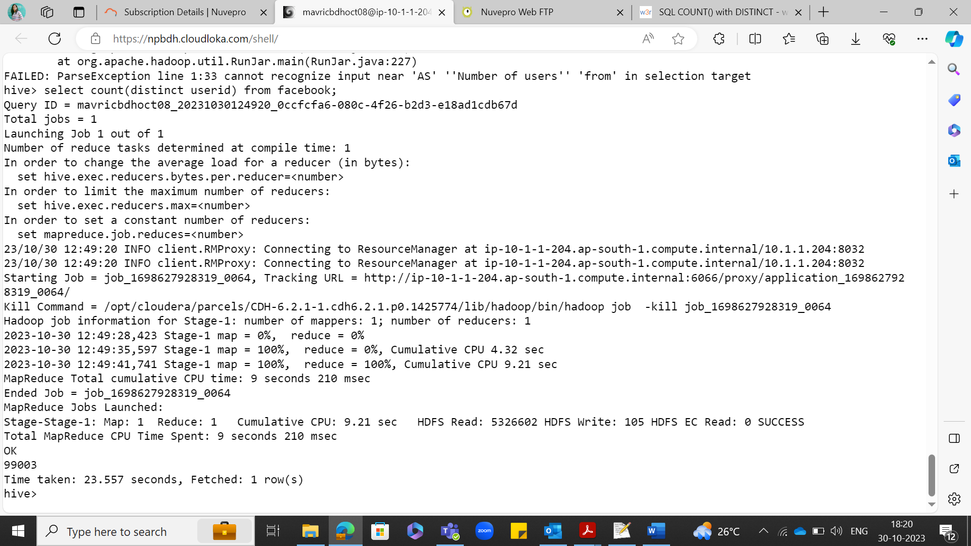

**Q2: Find out the no of users above the age of 25**

select count(*) from facebook where age > 25;

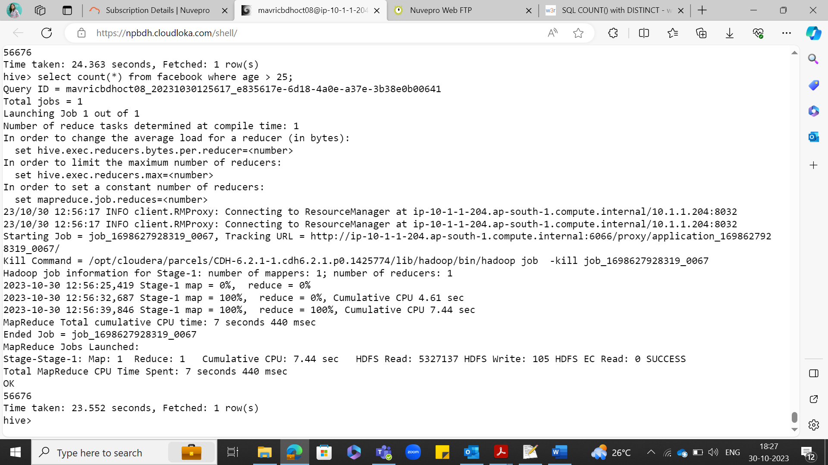

**Q3. Do male face book users tend to have more friends or female users**

select gender, sum(friend_count) from facebook group by gender;

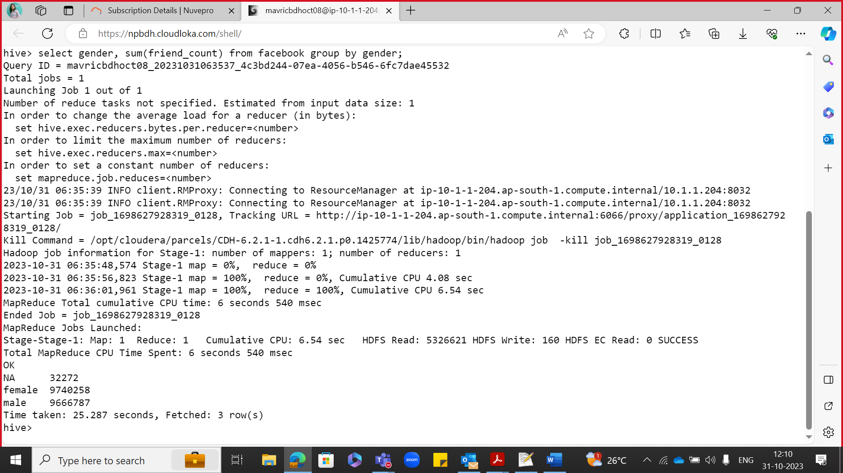

**Q4: How many likes do young people receive on facebook as opposed to old people**

select 'Young' as people ,sum(likes_received) as total_likes from facebook where age <= 18

union

select 'OLD' as people ,sum(likes_received) as total_likes from facebook where age > 18)a;

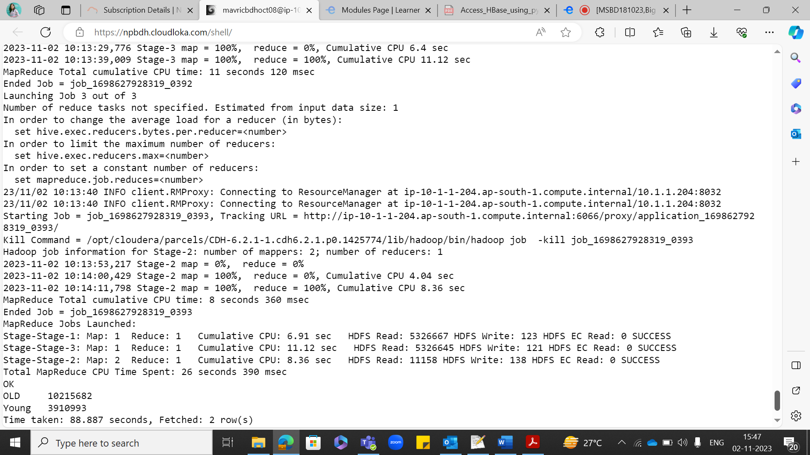

select sum(likes_received) from facebook where age between 13 and 20;

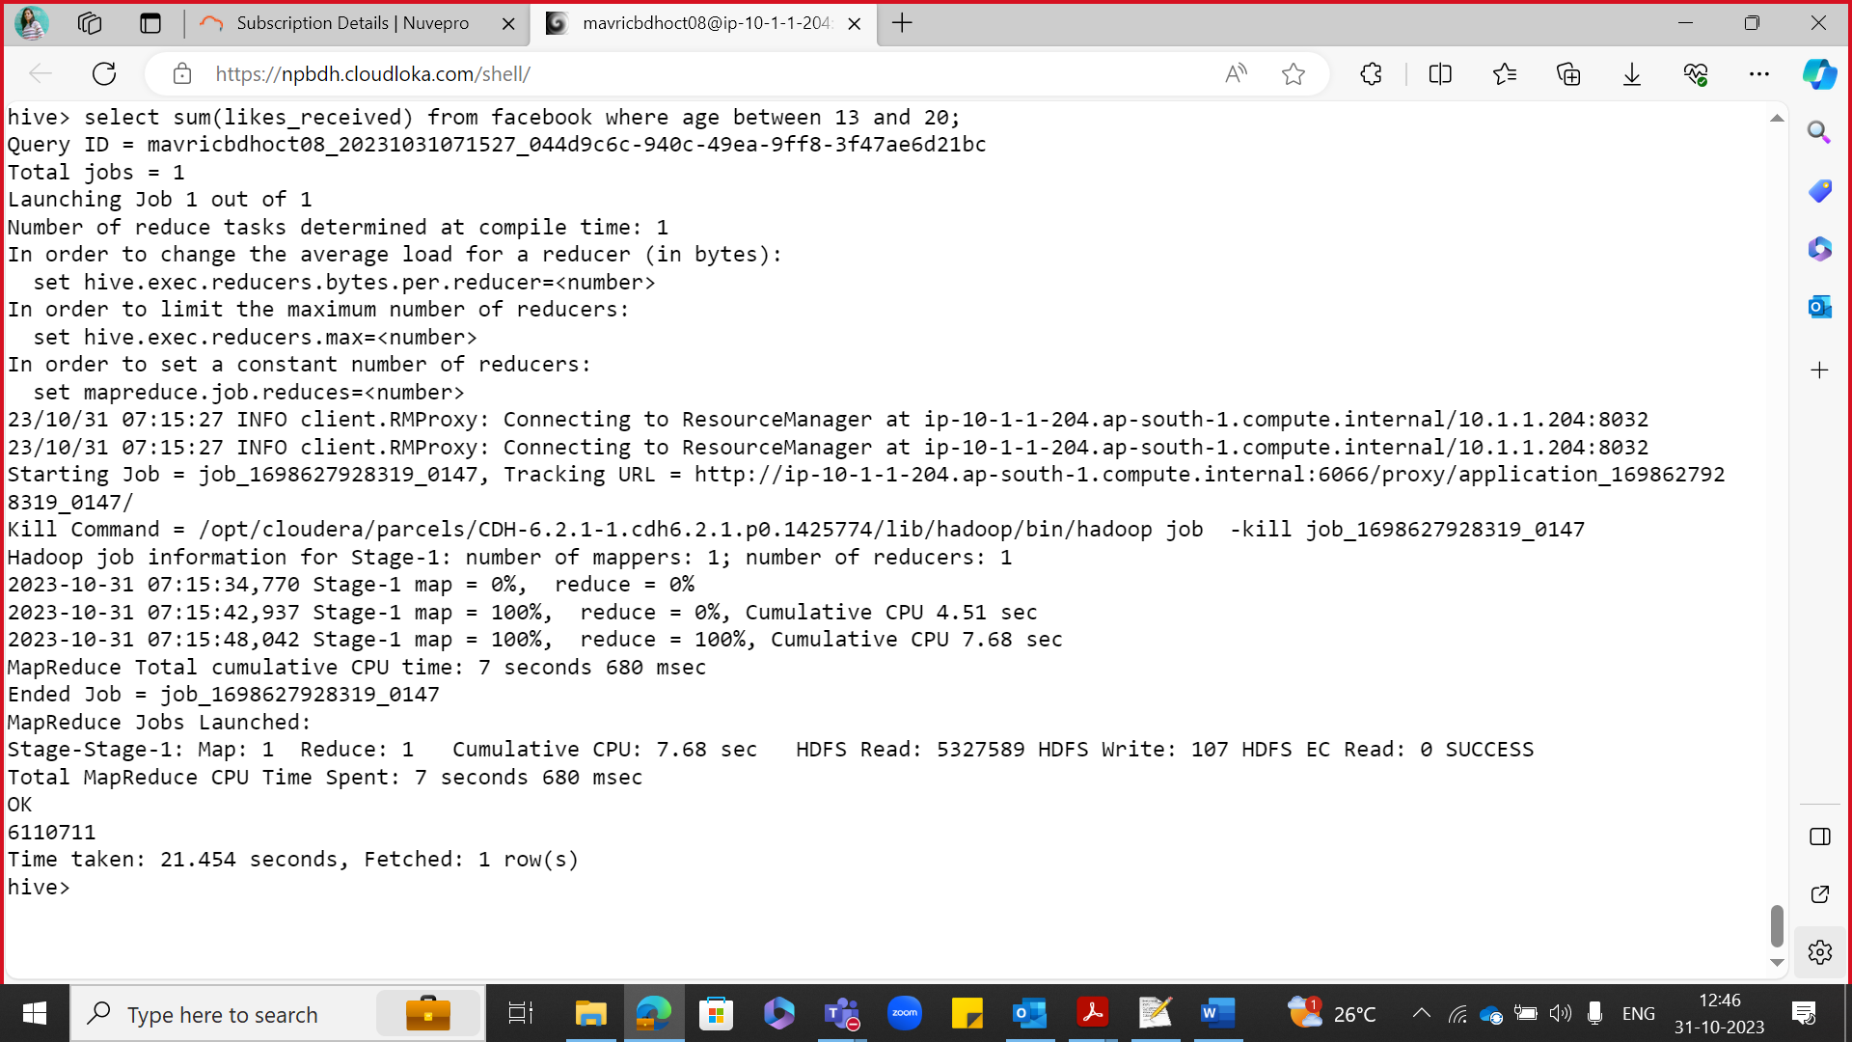

select sum(likes_received) from facebook where age between 21 and 115;

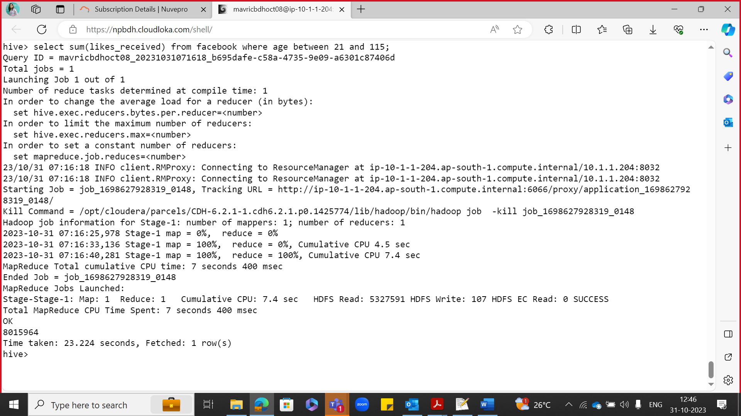

**Q5: Find out the count of facebook users for each birthday month**

select dob_month,count(userid) from facebook group by dob_month;

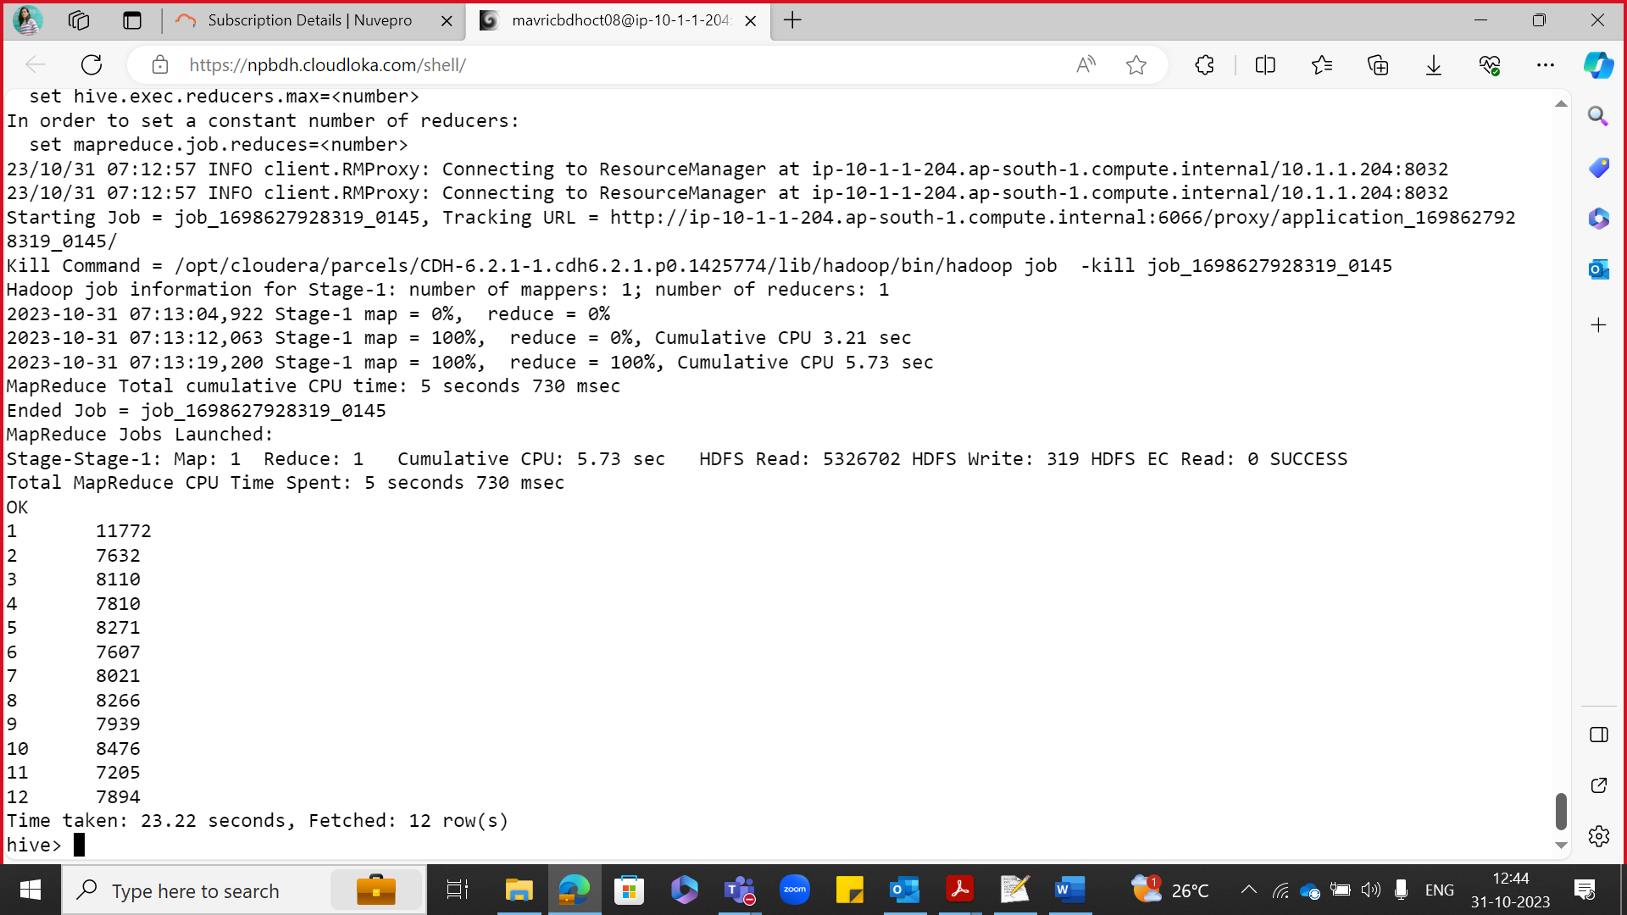

**Q6:Do young members use mobile phones or computers for facebook browsing**

select sum(mobile_likes),sum(www_likes) from facebook where age <=18;

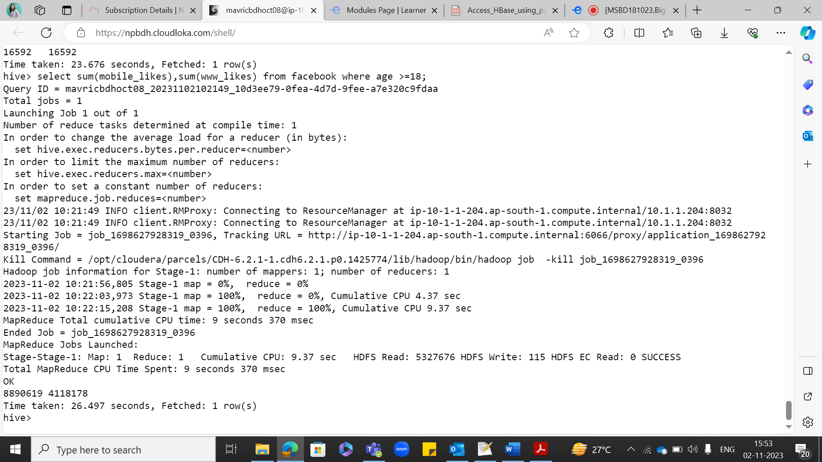

**Q7:Do adult members use mobile phones or computers for facebook browsing**

Select sum(mobile_likes),sum(www_likes) from facebook where age >18;

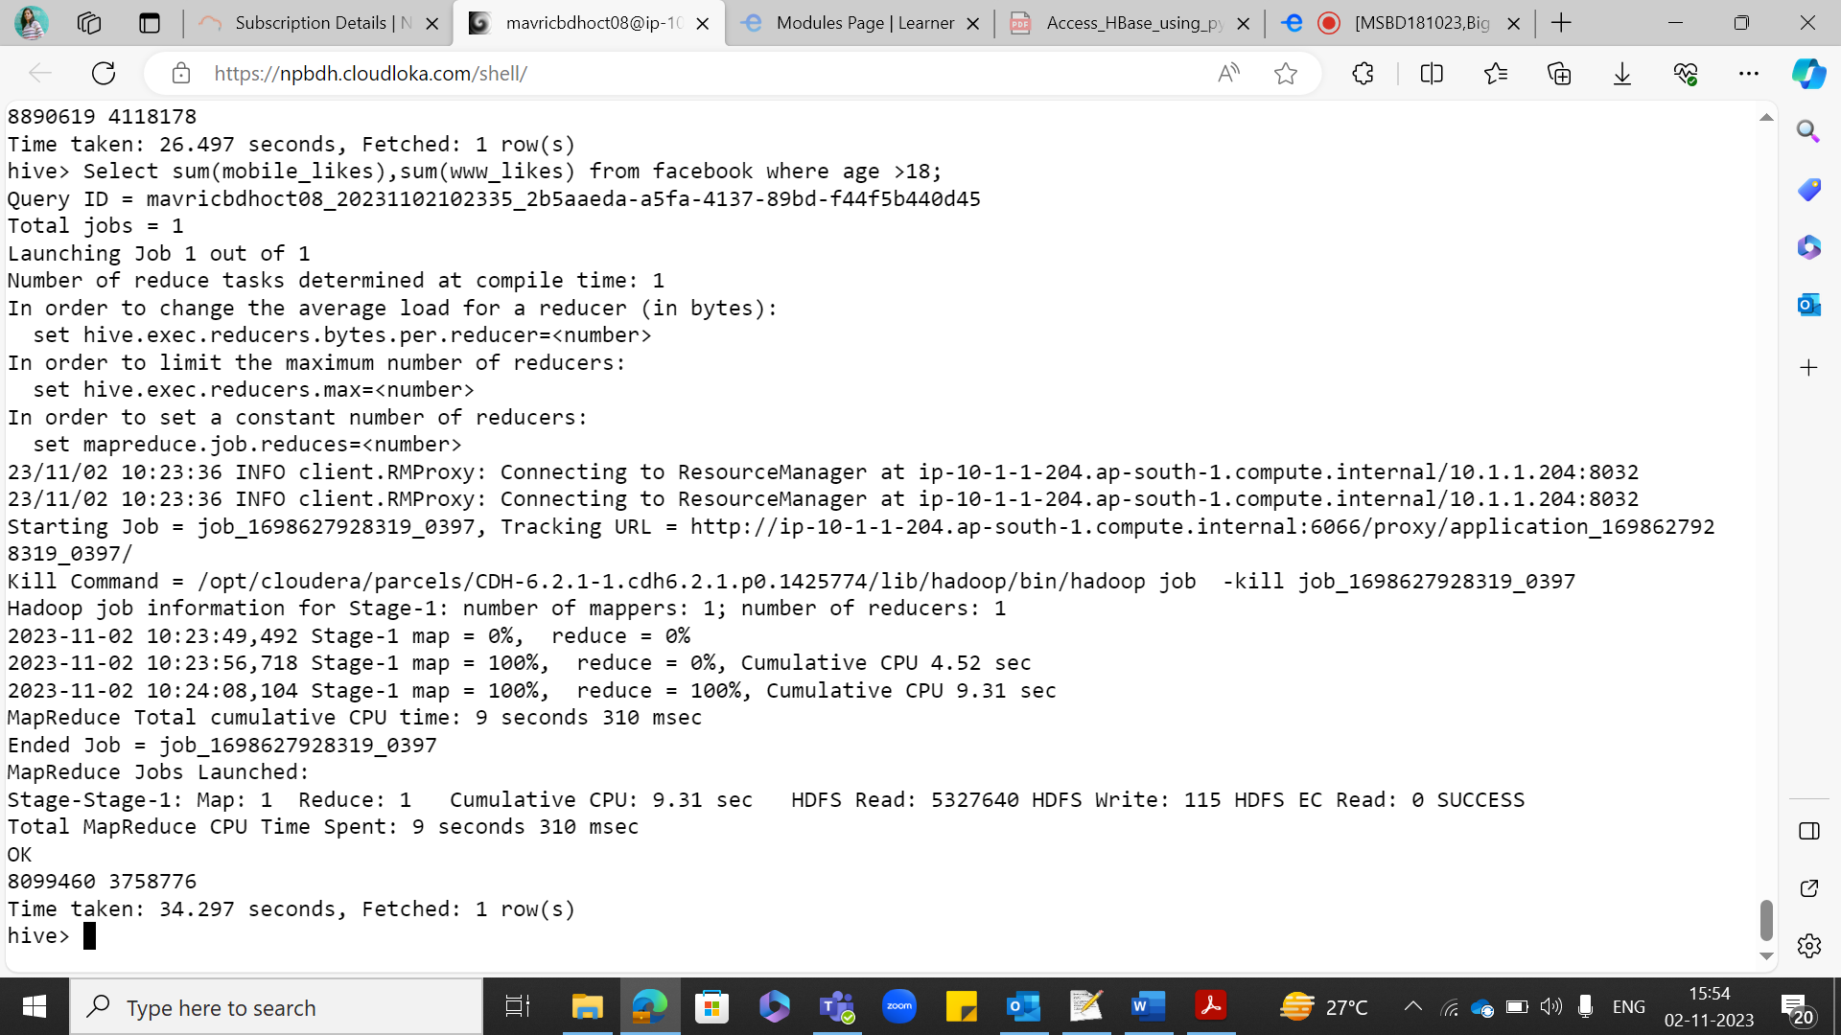

**Assignment 3 ontime flight performances:**

**Steps completed in HDFS:**

hdfs dfs -mkdir indhuAirlinesOntimeAnalysis

hdfs dfs -put 2003.csv.bz2 indhuAirlinesOntimeAnalysis

hdfs dfs -put 2004.csv.bz2 indhuAirlinesOntimeAnalysis

hdfs dfs -put 2005.csv.bz2 indhuAirlinesOntimeAnalysis

hdfs dfs -put airports.csv indhuAirlinesOntimeAnalysis

hdfs dfs -put carriers.csv indhuAirlinesOntimeAnalysis

hdfs dfs -put plane-data.csv indhuAirlinesOntimeAnalysis

bzip2 -dk 2003.csv.bz2

bzip2 -dk 2004.csv.bz2

bzip2 -dk 2005.csv.bz2

hdfs dfs -put 2003.csv indhuAirlinesOntimeAnalysis

hdfs dfs -put 2004.csv indhuAirlinesOntimeAnalysis

hdfs dfs -put 2005.csv indhuAirlinesOntimeAnalysis

hdfs dfs -mkdir rawdata/airline/airport

hdfs dfs -mkdir rawdata/airline/flights

hdfs dfs -mkdir rawdata/airline/carriers

hdfs dfs -mkdir rawdata/airline/planeinfo

hdfs dfs -cp indhuAirlinesOntimeAnalysis/airports.csv rawdata/airline/airport

hdfs dfs -cp indhuAirlinesOntimeAnalysis/200* rawdata/airline/flights

hdfs dfs -cp indhuAirlinesOntimeAnalysis/plane-data.csv rawdata/airline/planeinfo

hdfs dfs -cp indhuAirlinesOntimeAnalysis/carriers.csv rawdata/airline/carriers

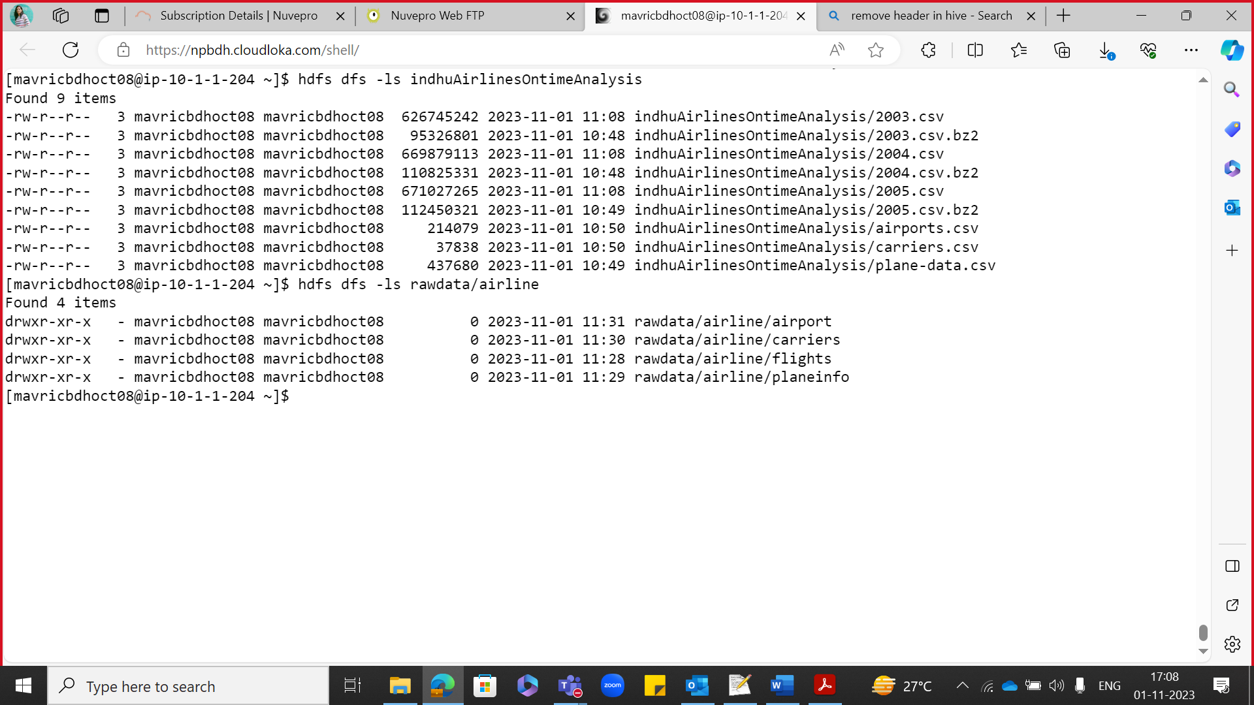

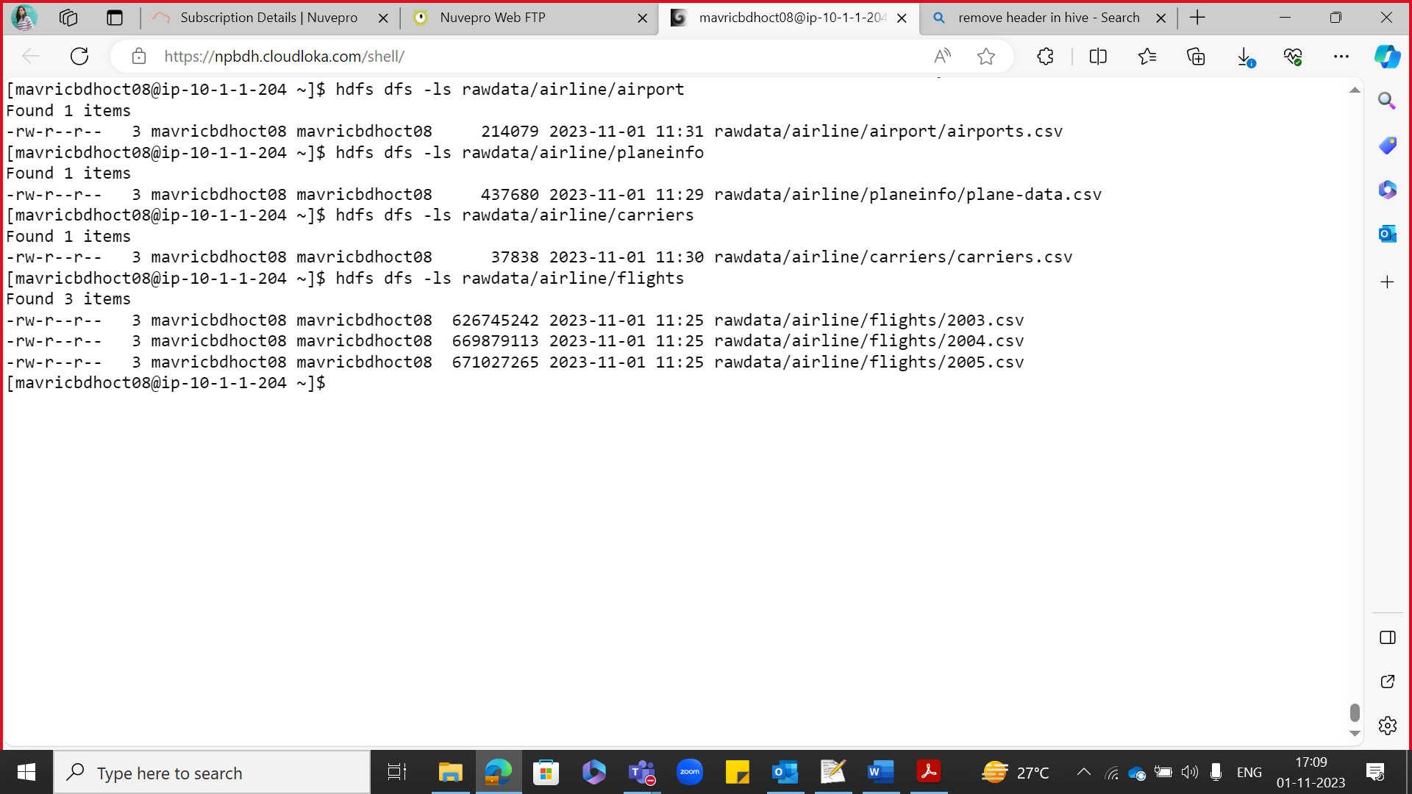

create database indhuairline_db;

use indhuairline_db;

create EXTERNAL TABLE airports_stg (iata string,airport string,city string,state string,country string,lat decimal,long decimal) ROW FORMAT DELIMITED FIELDS TERMINATED BY ',' location '/user/mavricbdhoct08/rawdata/airline/airport';

create EXTERNAL TABLE carrier_stg (code string,description string) ROW FORMAT DELIMITED FIELDS TERMINATED BY ',' location '/user/mavricbdhoct08/rawdata/airline/carriers';

create EXTERNAL TABLE planeinfo_stg (tailNum string, type string, manufacturer string, issue_date string, model string, status string,aircraft_type string,engine_type string, year int) ROW FORMAT DELIMITED FIELDS TERMINATED BY ',' location '/user/mavricbdhoct08/rawdata/airline/planeinfo';

create EXTERNAL TABLE flights_stg ( Year int ,Month int,DayofMonth int,DayOfWeek int,DepTime int,CRSDepTime int,ArrTime int ,CRSArrTime int, UniqueCarrier string, FlightNum string,TailNum string, ActualElapsedTime int, CRSElapsedTime int, AirTime int, ArrDelay int, DepDelay int, Origin string, Dest string, Distance int, TaxiIn string, TaxiOut string, Cancelled string,CancellationCode string, Diverted string, CarrierDelay int, WeatherDelay int,NASDelay int,SecurityDelay int,LateAircraftDelay int)ROW FORMAT DELIMITED FIELDS TERMINATED BY ',' location '/user/mavricbdhoct08/rawdata/airline/flights';

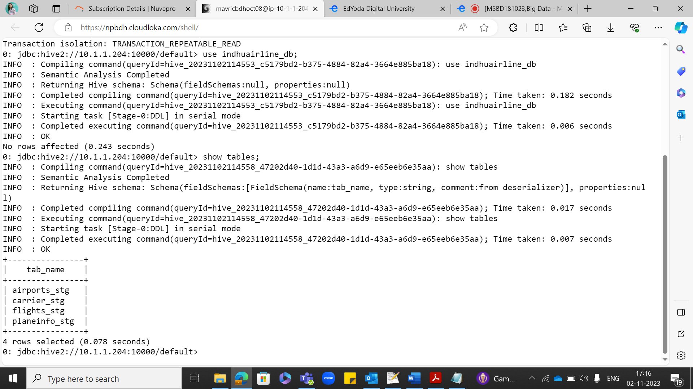

Select * from airports_stg limit 10;

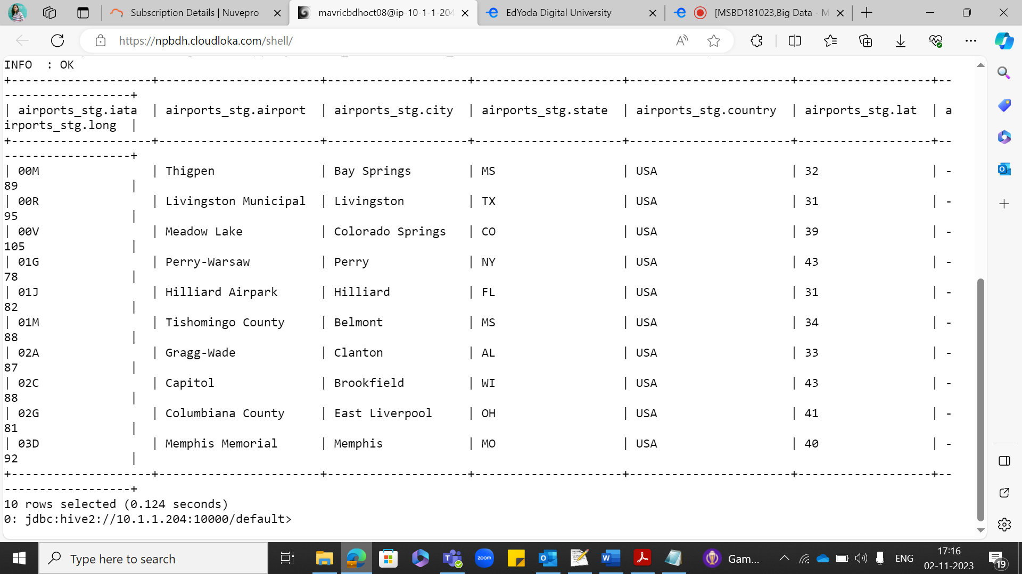

Select * from carrier_stg limit 10;

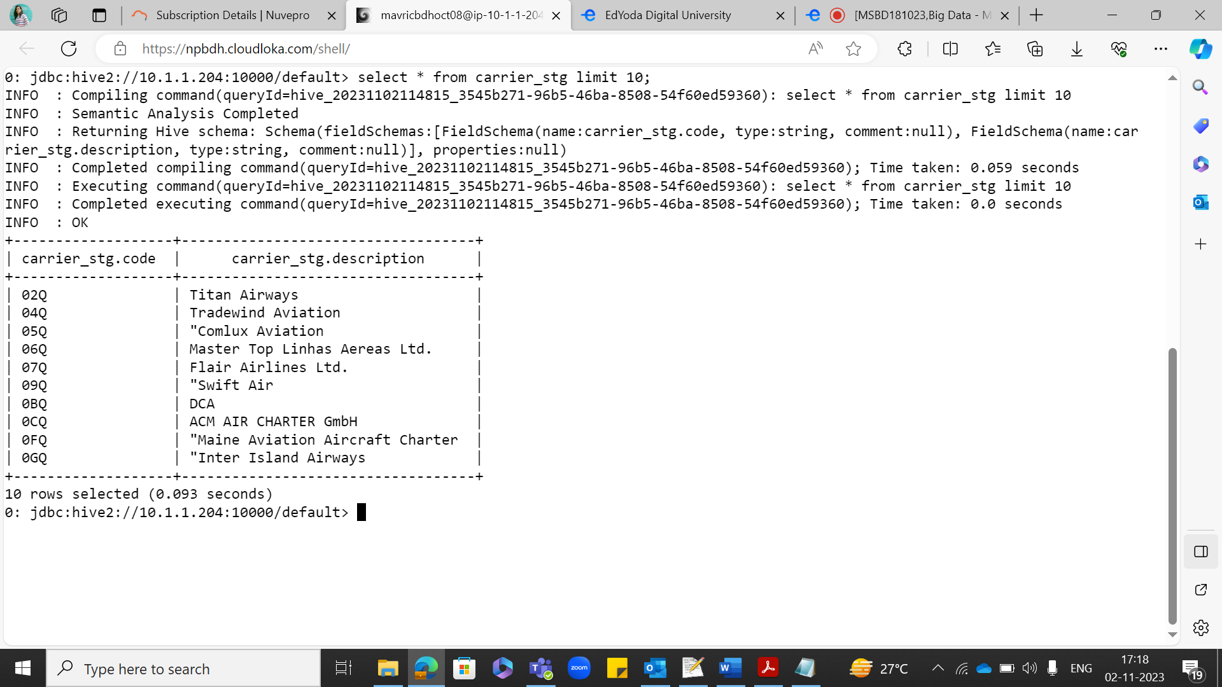

Select count(*) from flights_stg ;

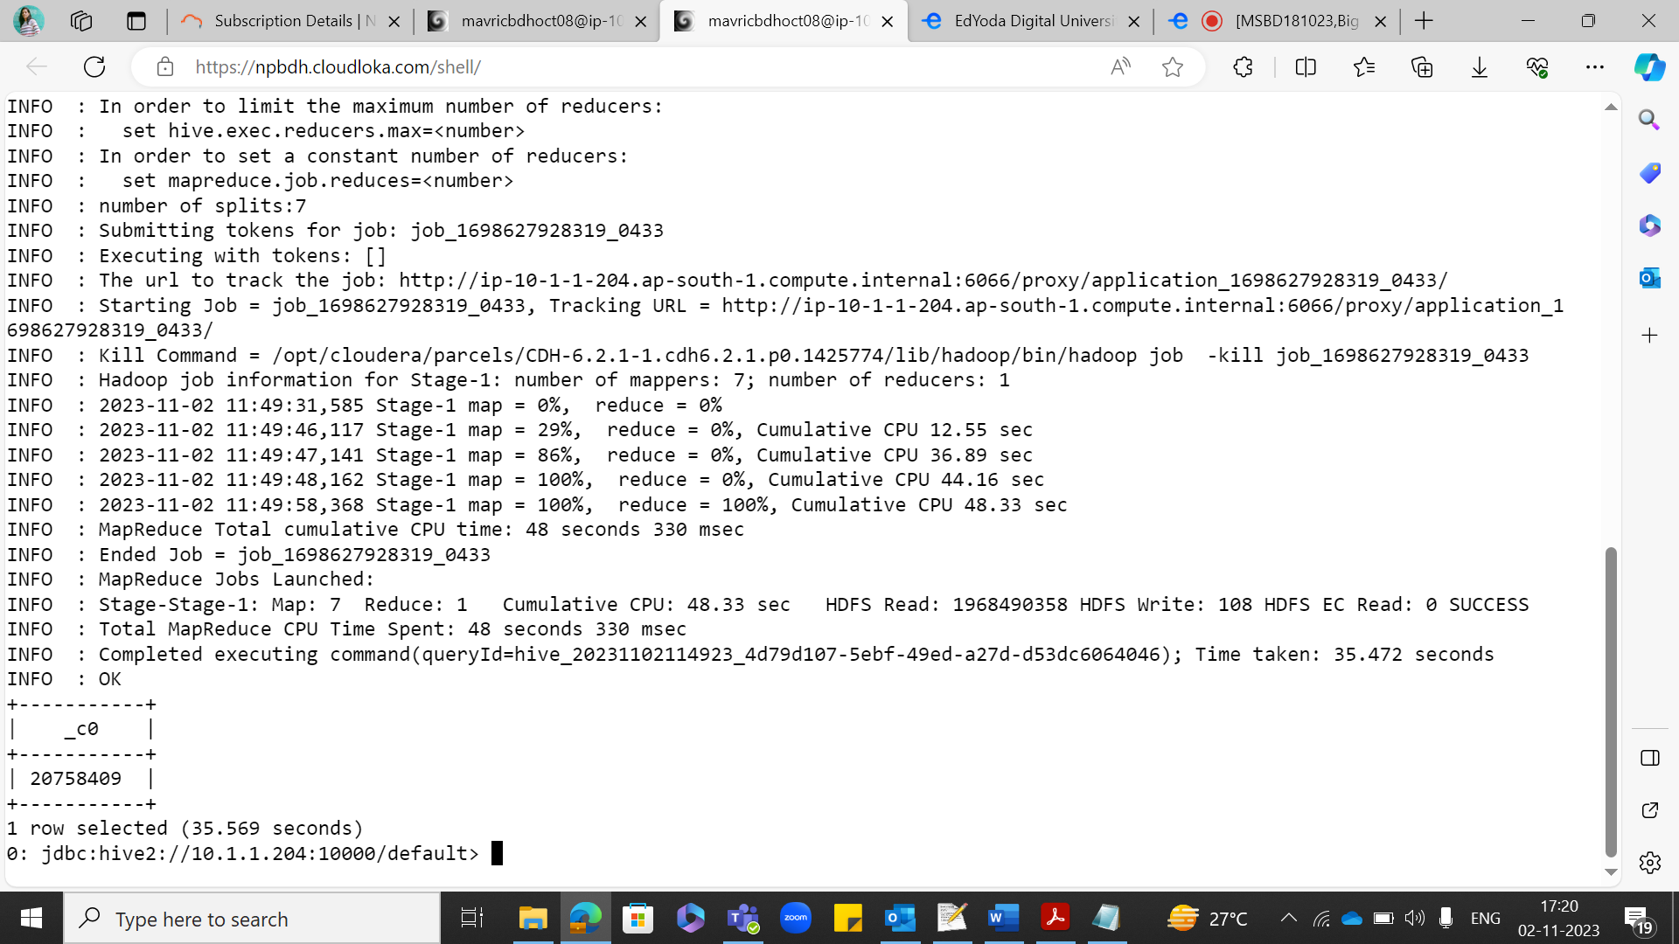

**What is the average arrival delay and average departure delay in each month of the year 2004?**

select Month,avg(ArrDelay) as arrival_delay, avg(DepDelay) as depature_delay from flights_stg where year=2004 group by month;

Time taken: 57.19 seconds

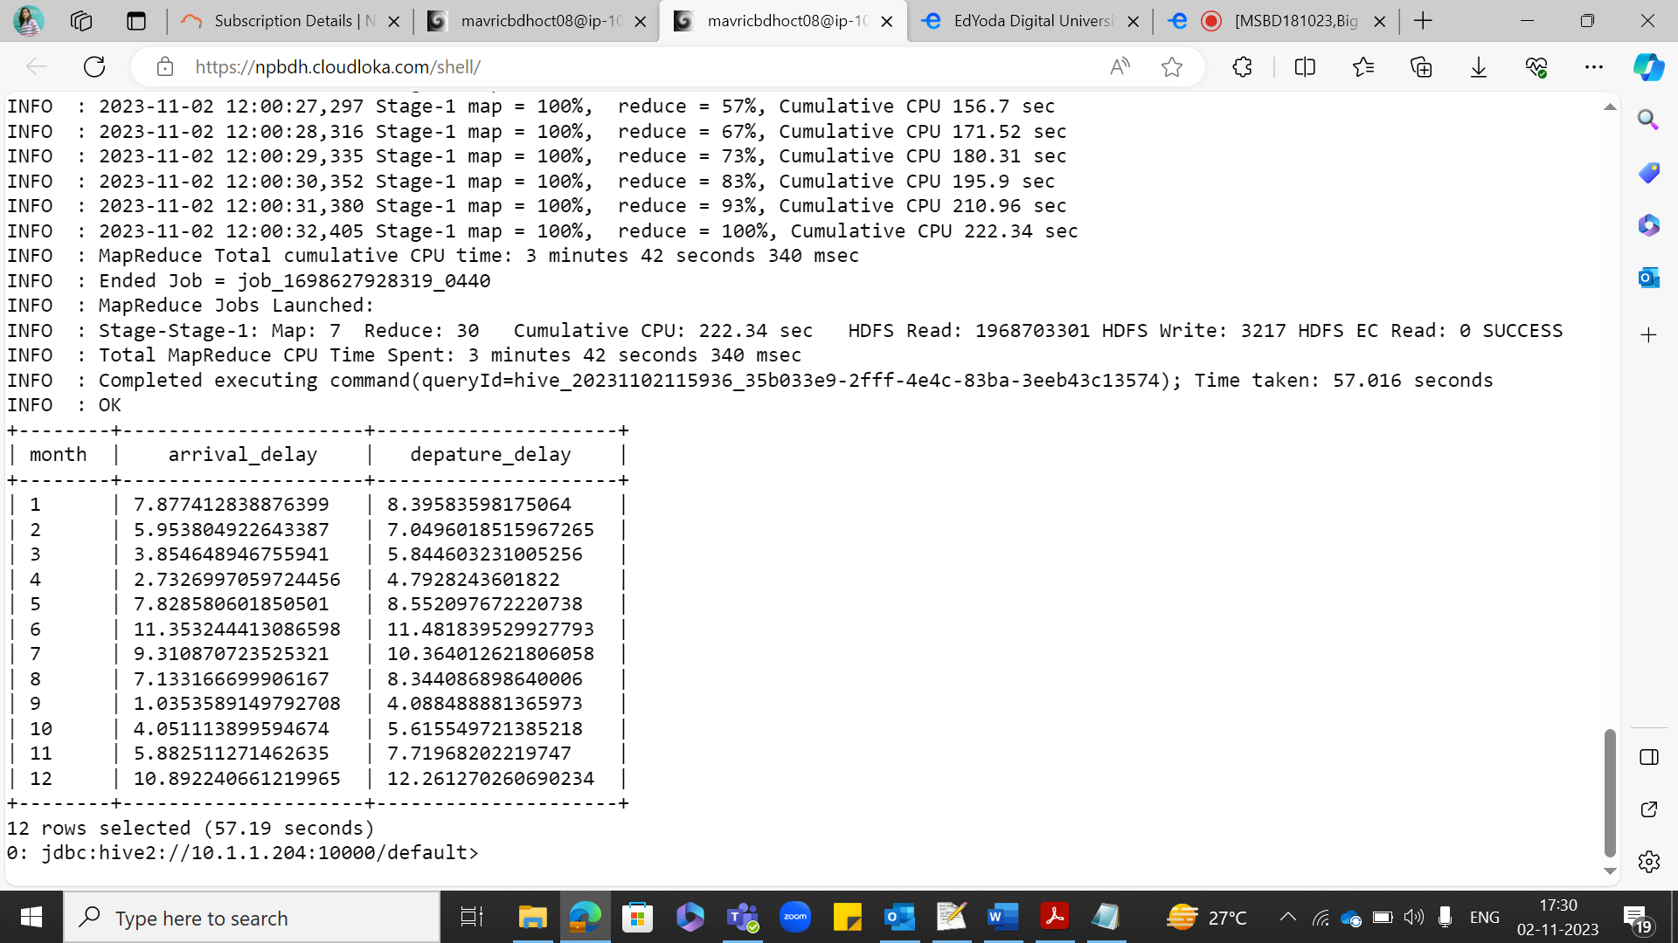

**PARQUET TABLE CREATION:**

create EXTERNAL TABLE flights_pq ( Year int ,Month int,DayofMonth int,DayOfWeek int,DepTime int,CRSDepTime int,ArrTime int ,CRSArrTime int, UniqueCarrier string, FlightNum string,TailNum string, ActualElapsedTime int, CRSElapsedTime int, AirTime int, ArrDelay int, DepDelay int, Origin string, Dest string, Distance int, TaxiIn string, TaxiOut string, Cancelled string,CancellationCode string, Diverted string, CarrierDelay int, WeatherDelay int,NASDelay int,SecurityDelay int,LateAircraftDelay int) STORED AS PARQUET location'/user/mavricbdhoct08/output/airline/pq_flights';

insert overwrite table flights_pq select * from flights_stg;

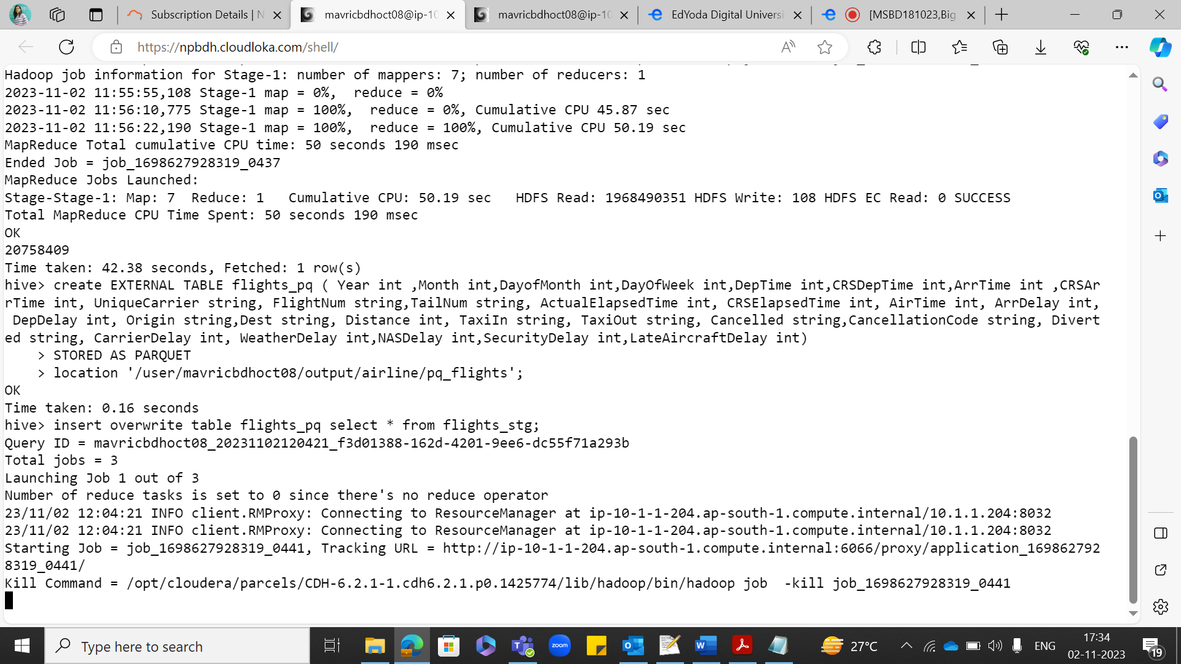

**select * from flights_pq limit 10;**

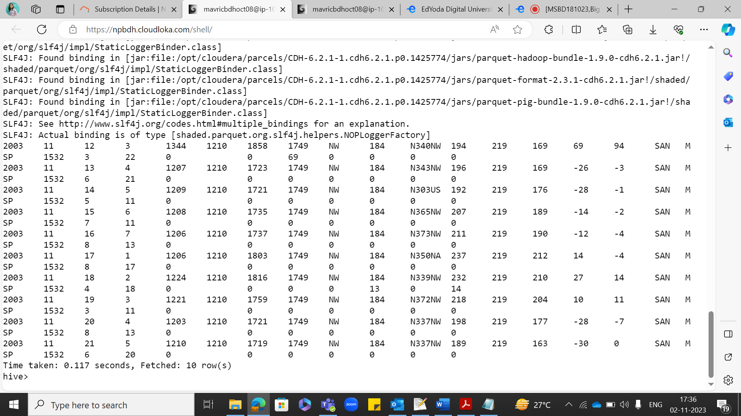

select Month,avg(ArrDelay) as arrival_delay, avg(DepDelay) as depature_delay from flights_pq where year=2004 group by month;

Time taken: 42.403 seconds

